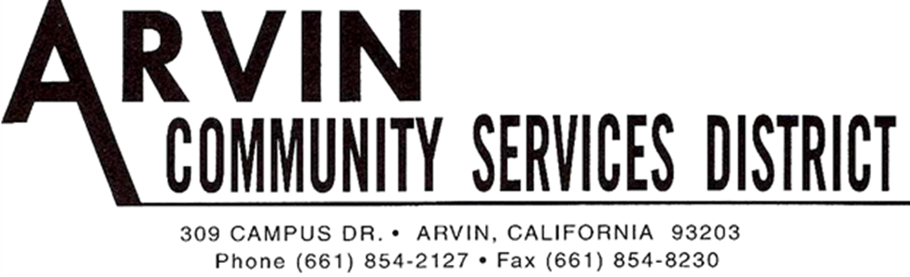

SPECIAL MEETING AGENDA OF THE
ARVIN COMMUNITY SERVICES DISTRICT BOARD OF DIRECTORS
Monday September 23, 2019 6:00 P.M.

*******************************************************
Call Meeting to Order Board President Gallardo

Roll Call: Rafael Gallardo President
Maria Alvarez Vice President
Cynthia Moran Board Director
Robert Rodriguez Board Director
Aurelio Reyna Board Director
************************************************************************************ Raul Barraza, Jr. General Manager
Alan Peake District Counsel
Dee Jaspar District Engineer
************************************************************************************
This meeting is held in accordance with the Brown Act. Individuals may address the Board on any matter listed on this agenda, excluding closed session. Members of the public desiring to address the Board must request recognition from the Board President. Presentation by members of the public is limited to two minutes each per agenda item.

Flag Salute: Board and audience salute flag.

- Public Comment:
This portion of the meeting is set aside for members of the public to address any matter not on this agenda and over which the Board has jurisdiction. Comments are limited to 2 minutes for each person and 15 minutes on each subject.

Motion to go into closed session made by ___________ and seconded by _____________
Director ____________________, seconded Director____________________
Roll Call: BD Rodriguez__ BD Reyna __ BD Moran__ VP Alvarez__ BP Gallardo__

- Closed Session
  - Conference with Labor Negotiators: General Manager and District Legal Counsel: Laborers International Union of North America 777 Gov’t Code 54957.6

  - Conference with Legal Counsel on existing litigation: Arvin CSD v. Dow Chemical and Shell Oil Company Government Code Section 54956.9 (d) (i)

Motion to go into back into open session made by ___________ and seconded by _____________
Director ____________________, seconded Director____________________
Roll Call: BD Rodriguez__ BD Reyna __ BD Moran__ VP Alvarez__ BP Gallardo__

Report from Closed Session:
- ________________________________________________________________________
- ________________________________________________________________________

- Adjournment:

Motion: ___________________________________________________________________
Director ________________________, seconded Director___________________________
Roll Call: BD Rodriguez__ BD Reyna __ BD Moran__ VP Alvarez__ BP Gallardo__

I hereby certify under perjury under the laws of the State of California that the foregoing agenda was posted on the Arvin Community Services office window not less than 24 hours prior to the meeting dated September 23, 2019.

_____________________________
Raul Barraza, Jr.
Board Secretary/General Manager

______________________________________________________________________________
AMERICANS with DISABILITIES ACT: In compliance with the ADA, if you need special assistance to participate in a District meeting or other services offered by the District, please contact the District Board Secretary's office (661) 854-2127. Notification of at least 24 hours prior to the meeting or time when services are needed will assist the District staff in assuring that reasonable arrangements can be made to provide accessibility to the meeting or services.

