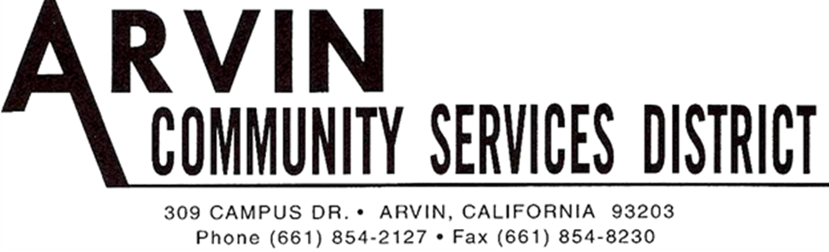

REGULAR MEETING AGENDA OF THE
ARVIN COMMUNITY SERVICES DISTRICT BOARD OF DIRECTORS
Monday, August 19, 2019 6:00 P.M.

*******************************************************
Call Meeting to Order Board President Gallardo

Roll Call: Rafael Gallardo President
Maria Alvarez Vice President
Cynthia Moran Board Director
Robert Rodriguez Board Director
Aurelio Reyna Board Director
************************************************************************************ Raul Barraza, Jr. General Manager
Alan Peake District Counsel
Dee Jaspar District Engineer
************************************************************************************
This meeting is held in accordance with the Brown Act. Individuals may address the Board on any matter listed on this agenda, excluding closed session. Members of the public desiring to address the Board must request recognition from the Board President. Presentation by members of the public is limited to two minutes each per agenda item.

Flag Salute: Board and audience salute flag.

- Public Comment:
This portion of the meeting is set aside for members of the public to address any matter not on this agenda and over which the Board has jurisdiction. Comments are limited to 2 minutes for each person and 15 minutes on each subject.

- Consent Calendar
The Consent Calendar consists of items that in staff’s opinion are routine and non-controversial. These items are approved in one motion unless a Board Member or member of the public removes a particular item.

  - Approval of Regular Meeting August 5, 2019
  - Approval of Special Meeting August 12, 2019
  - Accounts Payable for August 2019

Motion: ___________________________________________________________________
Director ____________________, seconded Director____________________
Roll Call: BD Rodriguez__ BD Reyna __ BD Moran__ VP Alvarez__ BP Gallardo__

- Approval to Distribute the General Sustainability Plan for Arvin Edison Water Storage District which includes Arvin Community Services District under the Kern Groundwater Authority
Motion: ____________________________________________________________________
Director __________________________, seconded Director___________________________
Roll Call: BD Rodriguez__ BD Reyna __ BD Moran__ VP Alvarez__ BP Gallardo__

- Progress Report for the Arsenic Mitigation Plan Phase II

- Staff Comments:
  - General Manager
  - Legal Counsel
  - District Engineer

- Board Member Comments:
This portion of the meeting is set aside to provide the Board with an opportunity to bring any new matters to the attention of the District. However, while no action can be taken on any matter discussed during this portion of the meeting, a Board Member may request that a subject be placed on an upcoming agenda. This portion of the meeting also allows the Board to get a brief update on any matter addressed at a previous meeting.

  - Director Rodriguez
  - Director Reyna
  - Director Moran
  - Vice President Alvarez
  - President Gallardo

Motion to go into closed session made by ___________ and seconded by _____________
Director ____________________, seconded Director____________________
Roll Call: BD Rodriguez__ BD Reyna __ BD Moran__ VP Alvarez__ BP Gallardo__

- Closed Session

  - Performance Evaluation General Manager – Government Code 54957

Motion to go into back into open session made by ___________ and seconded by _____________
Director ____________________, seconded Director____________________
Roll Call: BD Rodriguez__ BD Reyna __ BD Moran__ VP Alvarez__ BP Gallardo__

Report from Closed Session:
  - _________________________________________________________________

- Adjournment:

Motion: ___________________________________________________________________
Director ________________________, seconded Director___________________________
Roll Call: BD Rodriguez__ BD Reyna __ BD Moran__ VP Alvarez__ BP Gallardo__

I hereby certify under perjury under the laws of the State of California that the foregoing agenda was posted on the Arvin Community Services office window not less than 72 hours prior to the meeting dated August 19, 2019.

_____________________________
Raul Barraza, Jr.
Board Secretary/General Manager

______________________________________________________________________________
AMERICANS with DISABILITIES ACT: In compliance with the ADA, if you need special assistance to participate in a District meeting or other services offered by the District, please contact the District Board Secretary's office (661) 854-2127. Notification of at least 24 hours prior to the meeting or time when services are needed will assist the District staff in assuring that reasonable arrangements can be made to provide accessibility to the meeting or services.

