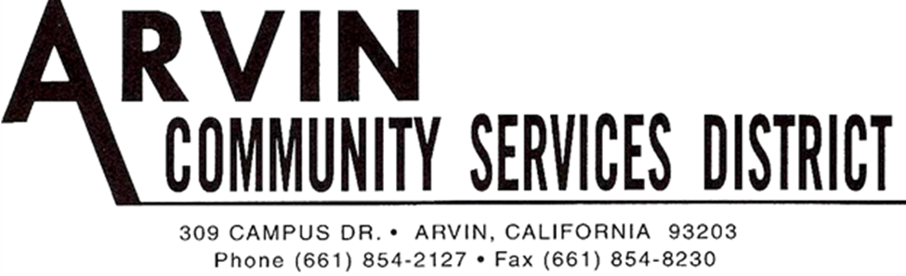

REGULAR MEETING AGENDA OF THE
ARVIN COMMUNITY SERVICES DISTRICT BOARD OF DIRECTORS
Monday, April 15, 2019 6:00 P.M.

*******************************************************
Call Meeting to Order Board President Gallardo

Roll Call: Rafael Gallardo President
Maria Alvarez Vice President
Cynthia Moran Board Director
Robert Rodriguez Board Director
Aurelio Reyna Board Director
************************************************************************************ Raul Barraza, Jr. General Manager
Alan Peake District Counsel
Dee Jaspar District Engineer
************************************************************************************
This meeting is held in accordance with the Brown Act. Individuals may address the Board on any matter listed on this agenda, excluding closed session. Members of the public desiring to address the Board must request recognition from the Board President. Presentation by members of the public is limited to two minutes each per agenda item.

Flag Salute: Board and audience salute flag.

- Public Comment:
This portion of the meeting is set aside for members of the public to address any matter not on this agenda and over which the Board has jurisdiction. Comments are limited to 2 minutes for each person and 15 minutes on each subject.

- Consent Calendar
The Consent Calendar consists of items that in staff’s opinion are routine and non-controversial. These items are approved in one motion unless a Board Member or member of the public removes a particular item.

  - Approval of Regular Meeting April 1, 2019
  - Accounts Payable for April 2019

Motion: ___________________________________________________________________
Director ____________________, seconded Director____________________
Roll Call: BD Rodriguez__ BD Reyna __ BD Moran__ VP Alvarez__ BP Gallardo__

- Board to discuss and take action re: Approval of Investigative Services Agreement between MMJ Solutions, Inc. and Arvin CSD
Motion: ___________________________________________________________________
Director ____________________, seconded Director____________________
Roll Call: BD Rodriguez__ BD Reyna __ BD Moran__ VP Alvarez__ BP Gallardo__

- Presentation: Monthly Operations Review for March 2019

- Board to discuss and take action re: Approval of Bid Proposal Recommendation for the EPA Replacement Well – Well No. 12 Well Drilling Project from Nor-Cal Pump & Well Drilling, Inc. in the amount of $743,620.

Motion: ___________________________________________________________________
Director ____________________, seconded Director____________________
Roll Call: BD Rodriguez__ BD Reyna __ BD Moran__ VP Alvarez__ BP Gallardo__

- Board to discuss and take action re: Approval of Bid Proposal Recommendation for the Arsenic Mitigation Project Phase II from W.M. Lyles Co. in the amount of $11,210,288

Motion: ___________________________________________________________________
Director ____________________, seconded Director____________________
Roll Call: BD Rodriguez__ BD Reyna __ BD Moran__ VP Alvarez__ BP Gallardo__

- Board to discuss and take action re: Resolution 19-01 Establishing a policy and rates for temporary meter services and adopting a district agreement for the same.

Motion: ___________________________________________________________________
Director ____________________, seconded Director____________________
Roll Call: BD Rodriguez__ BD Reyna __ BD Moran__ VP Alvarez__ BP Gallardo__

- Board to discuss and take action re: Approval of District Package Insurance Proposal for 2019-2020 from Tolman and Wiker in the amount of $41,762

Motion: ___________________________________________________________________
Director ____________________, seconded Director____________________
Roll Call: BD Rodriguez__ BD Reyna __ BD Moran__ VP Alvarez__ BP Gallardo__

- Staff Comments:

  - General Manager
  - Legal Counsel
  - District Engineer

- Board Member Comments:
This portion of the meeting is set aside to provide the Board with an opportunity to bring any new matters to the attention of the District. However, while no action can be taken on any matter discussed during this portion of the meeting, a Board Member may request that a subject be placed on an upcoming agenda. This portion of the meeting also allows the Board to get a brief update on any matter addressed at a previous meeting.

  - Director Rodriguez
  - Director Reyna
  - Director Moran
  - Vice President Alvarez
  - President Gallardo

Motion to move into Closed Session

Director ________________________, seconded Director___________________________
Roll Call: BD Rodriguez__ BD Reyna __ BD Moran__ VP Alvarez__ BP Gallardo__

- Closed Session
- Conference with Labor Negotiators: General Manager and District Counsel: Employee Organization: Laborers International Union of North America 777 Gov’t Code 54957.6

Report from Closed Session:
____________________________________________________________________________________________________________________________________________________________

- Adjournment:

Motion: ___________________________________________________________________
Director ________________________, seconded Director___________________________
Roll Call: BD Rodriguez__ BD Reyna __ BD Moran__ VP Alvarez__ BP Gallardo__

I hereby certify under perjury under the laws of the State of California that the foregoing agenda was posted on the Arvin Community Services office window not less than 72 hours prior to the meeting dated April 15, 2019.

_____________________________
Raul Barraza, Jr.
Board Secretary/General Manager

______________________________________________________________________________
AMERICANS with DISABILITIES ACT: In compliance with the ADA, if you need special assistance to participate in a District meeting or other services offered by the District, please contact the District Board Secretary's office (661) 854-2127. Notification of at least 24 hours prior to the meeting or time when services are needed will assist the District staff in assuring that reasonable arrangements can be made to provide accessibility to the meeting or services.

